Stack Using Array
Aim:
To write a program to implement a stack using an array and
perform basic operations.
Algorithm:
Step 1: Start Begin program execution.
Step 2: Initialize Stack – Define a stack of size MAX (5).
Step 3: Initialize top – Set top = -1 to indicate the stack is empty.
Step 4: Display Main Menu – Show options: 1. Push 2. Pop 3. Display
4. Exit.
Step 5: Read User Choice – Read the choice from the user.
●If choice = 1, go to Push Operation Steps.
●If choice = 2, go to Pop Operation Steps.
●If choice = 3, go to Display Operation Steps.
●If choice = 4, go to Exit Operation Steps.
●Otherwise, print "Invalid choice" and return to Step 4 (Display Main
Menu).
➢Push ( ) Operation Steps (Choice = 1)
▪ Step P1: Check Stack Overflow – If top == MAX - 1,
print "Stack Overflow" and return to Step 4 (Display
Main Menu).

▪ Step P2: Read Item – Read the element to push from
the user.
▪ Step P3: Increment top – top = top + 1.
▪ Step P4: Assign Stack Element – stack[top] = item.
▪ Step P5: Print Success Message – Print "Element
pushed successfully" and return to Step 4 (Display
Main Menu).
➢Pop( ) Operation Steps (Choice = 2)
▪ Step O1: Check Stack Underflow – If top == -1, print
"Stack Underflow" and return to Step 4 (Display Main
Menu).
▪ Step O2: Print Popped Element – Print stack[top].
▪ Step O3: Decrement top – top = top - 1 and return to
Step 4 (Display Main Menu).
➢Display( ) Operation Steps (Choice = 3)
▪ Step D1: Check if Stack is Empty – If top == -1, print
"Stack is empty" and return to Step 4 (Display Main
Menu).
▪ Step D2: Loop Through Stack – For i = top down to 0,
print stack[i].
▪ Step D3: Return to Main Menu – Go back to Step 4
(Display Main Menu).
➢Exit( ) Operation Steps (Choice = 4)
▪ Step E1: Print Exit Message – Print "Exiting program".
▪ Step E2: End – Program execution

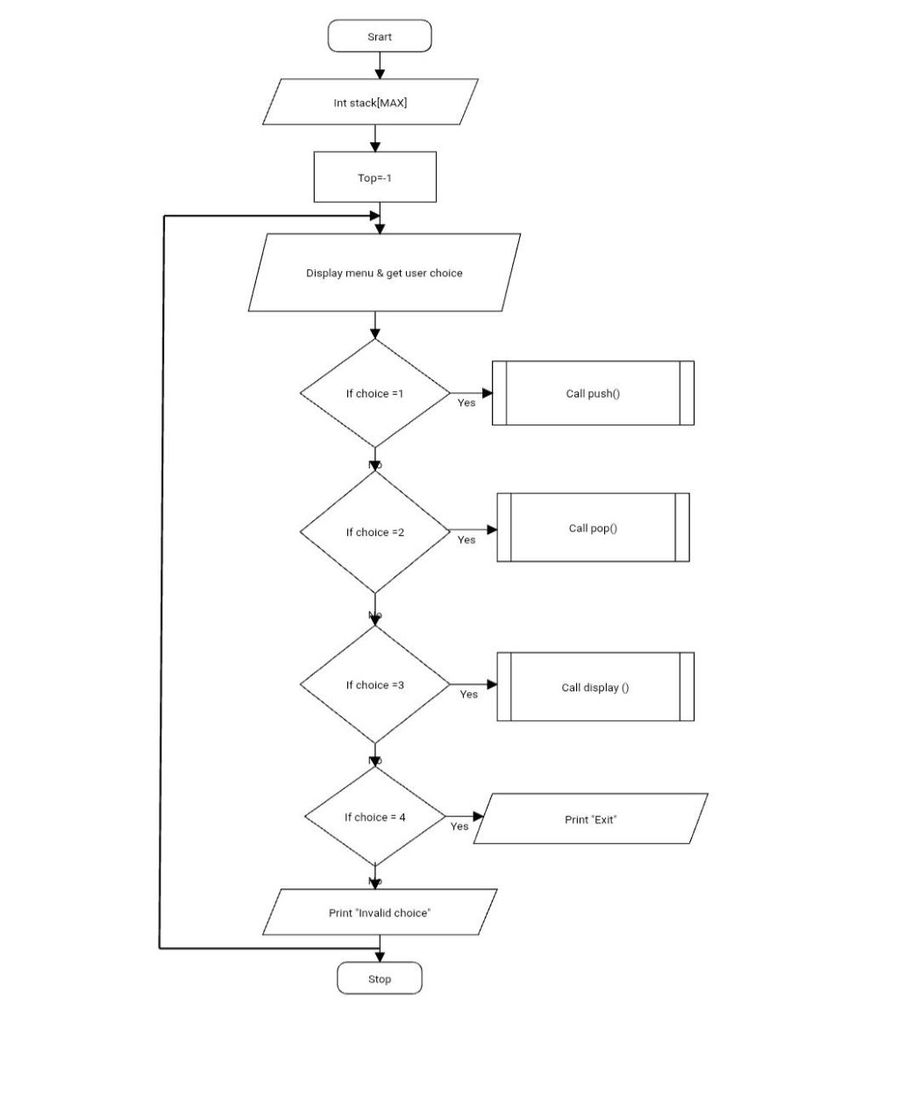

Flowchart:

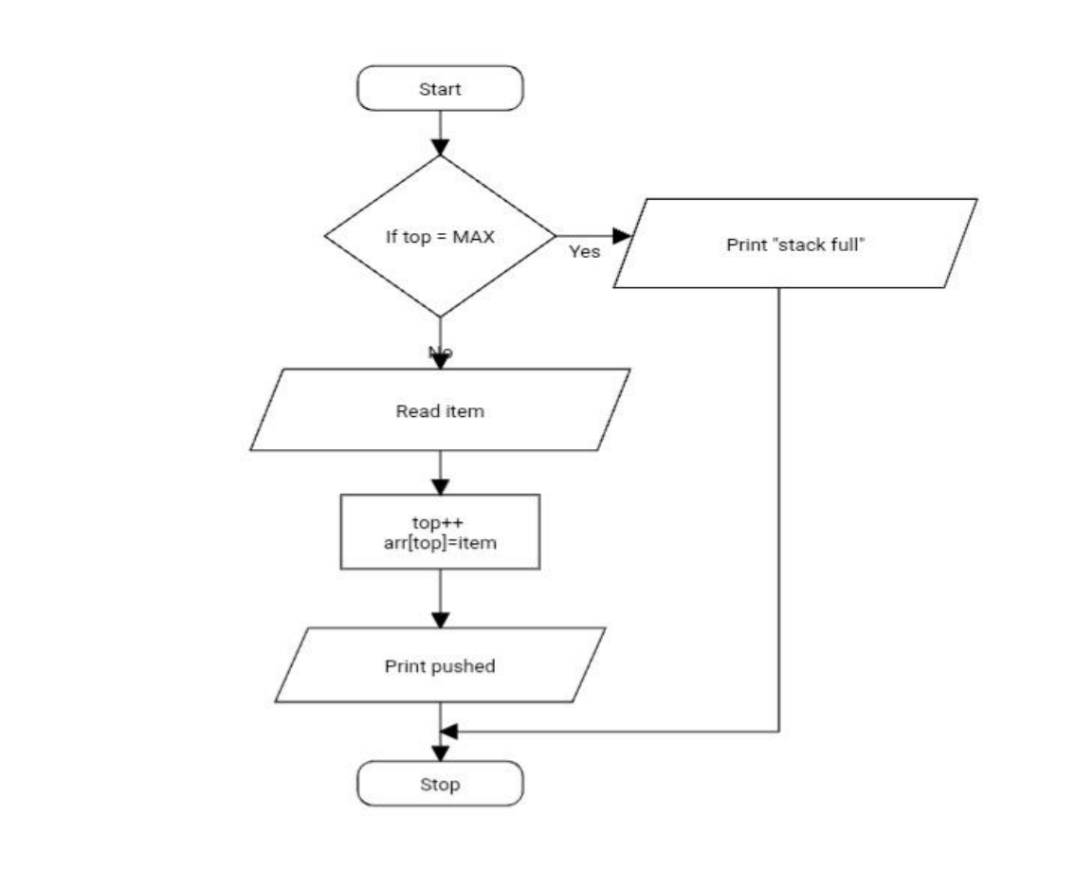

1.push()

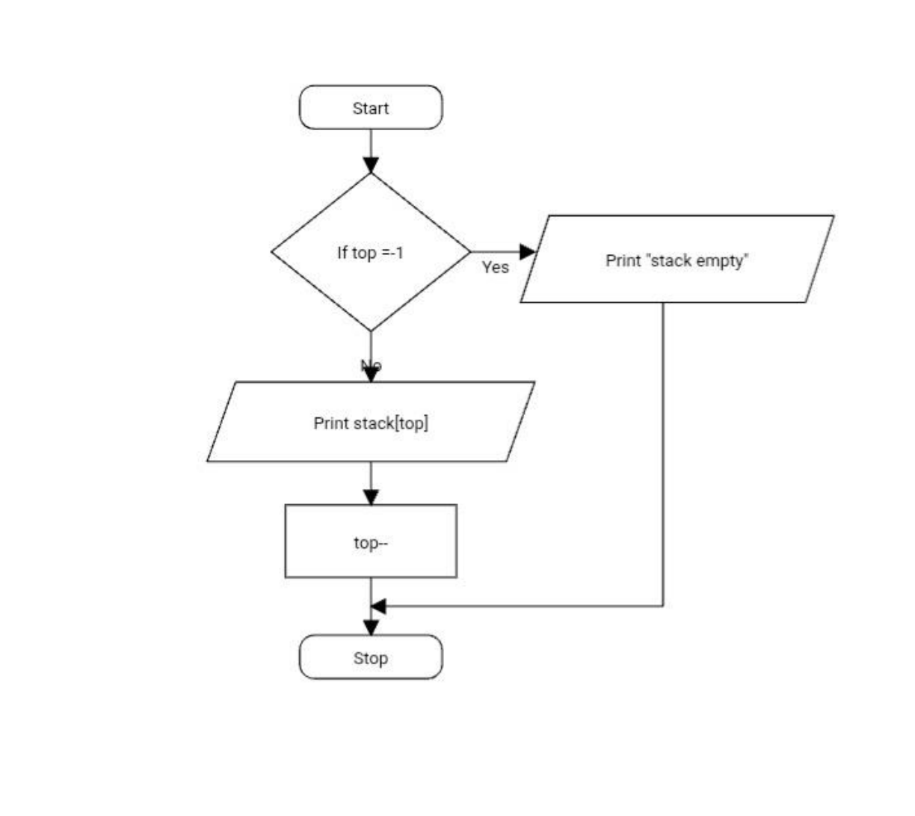

2.pop()

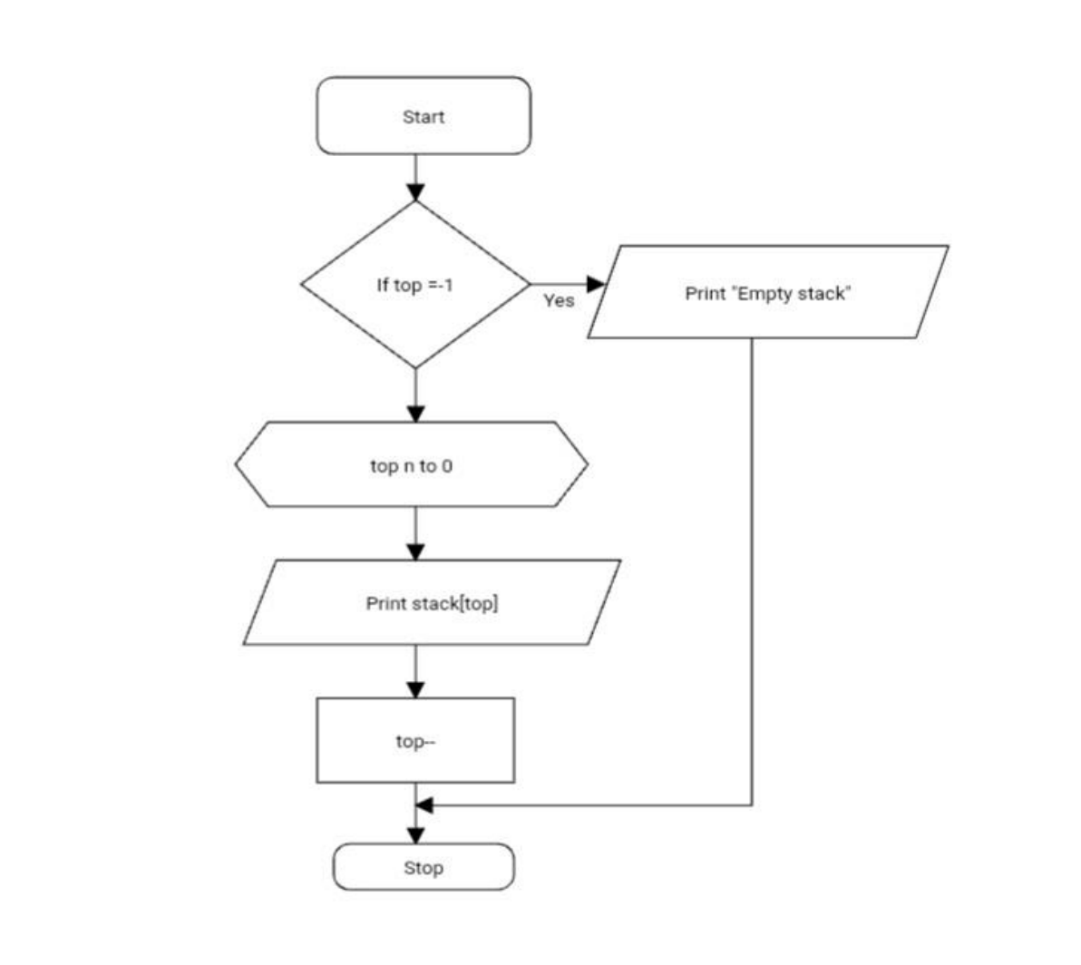

3.Display()

Source code:
#include <stdio.h>
#define MAX 5
int stack[MAX];
int top = -1;
// Push operation
void push()
{
int item;
if (top == MAX – 1)
{
Printf(“Stack Overflow!\n”);
return;
}
Printf(“Enter element to push: “);
Scanf(“%d”, &item);
Stack[++top] = item;

Printf(“Element pushed successfully.\n”);
}
// Pop operation
void pop()
{
if (top == -1)
{
Printf(“Stack Underflow!\n”);
return;
}
Printf(“Popped element: %d\n”, stack[top--]);
}
// Display stack elements
void display()
{
if (top == -1)
{

Printf(“Stack is empty.\n”);
return;
}
Printf(“Stack elements:\n”);
for (int i =choice;i>= 0; i--)
Printf(“%d\n”, stack[i]);
}
int main()
{
int choice;
do
{
Printf(“\n--- Stack Menu ---\n”);
Printf(“1. Push\n2. Pop\n3. Display\n4. Exit\n”);
Printf(“Enter your choice: “);
Scanf(“%d”, &choice);
switch (choice)
{

case 1:
push();
break;
case 2:
pop();
break;
case 3:
display();
break;
case 4:
printf(“Exiting program.\n”);
break;
default:
printf(“Invalid choice!\n”);
}
} while (choice != 4);
return 0;
}

OUTPUT:
--- Stack Menu ---
1. Push
2. Pop
3. Display
4. Exit
Enter your choice: 1
Enter element to push: 12
Element pushed successfully.
--- Stack Menu ---
1. Push
2. Pop
3. Display
4. Exit
Enter your choice: 1
Enter element to push: 13

Element pushed successfully.
--- Stack Menu ---
1. Push
2. Pop
3. Display
4. Exit
Enter your choice: 3
Stack elements:
13
12
--- Stack Menu ---
1. Push
2. Pop
.
3. Display
4. Exit

Enter your choice: 2
Popped element: 13
--- Stack Menu ---
1. Push
2. Pop
3. Display
4. Exit
Enter your choice: 3
Stack elements: 12
--- Stack Menu ---
1. Push
2. Pop
3. Display
4. Exit

Enter your choice:
4
Exiting program.
Result:
Thus the program is complied and verified successfully
with verified output.

